# Iteration 3

In this iteration reset Handicap, Handicap calculation was added and Form to save to the database. Submit round was altered and only if handicap exist case added. JUnit test was created to check the correctness of golf handicap calculation. SHA 256 cryptographic hash functions for passwords was added as well salt value created. Class diagram had major changes. User and Handicap classes become one to one relationships. Some changes in entity relationship diagram.

For the detailed development of the project please check GitHub repository: <https://github.com/yyyura/Project3>.

When creating a cryptographic hash function, a new value was added for password fields in 2.sql. The value was formed by adding a salt value to password and generated on <http://www.xorbin.com/tools/sha256-hash-calculator>.

## ERD - entity relationship diagram

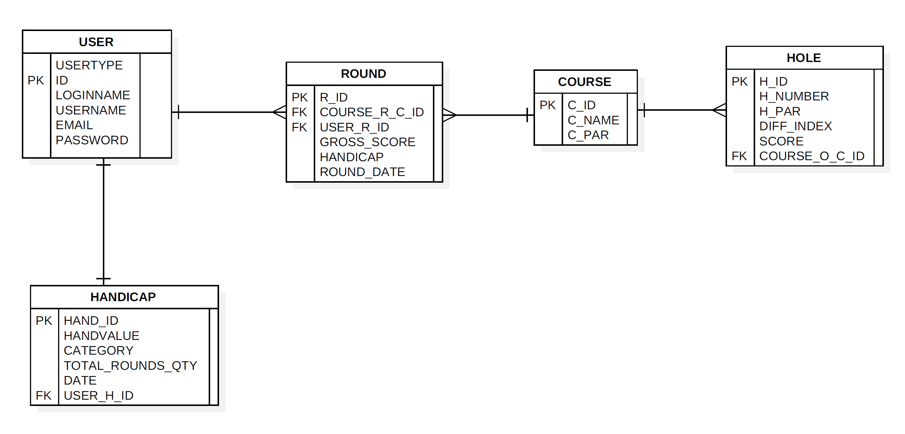

## Class Diagram

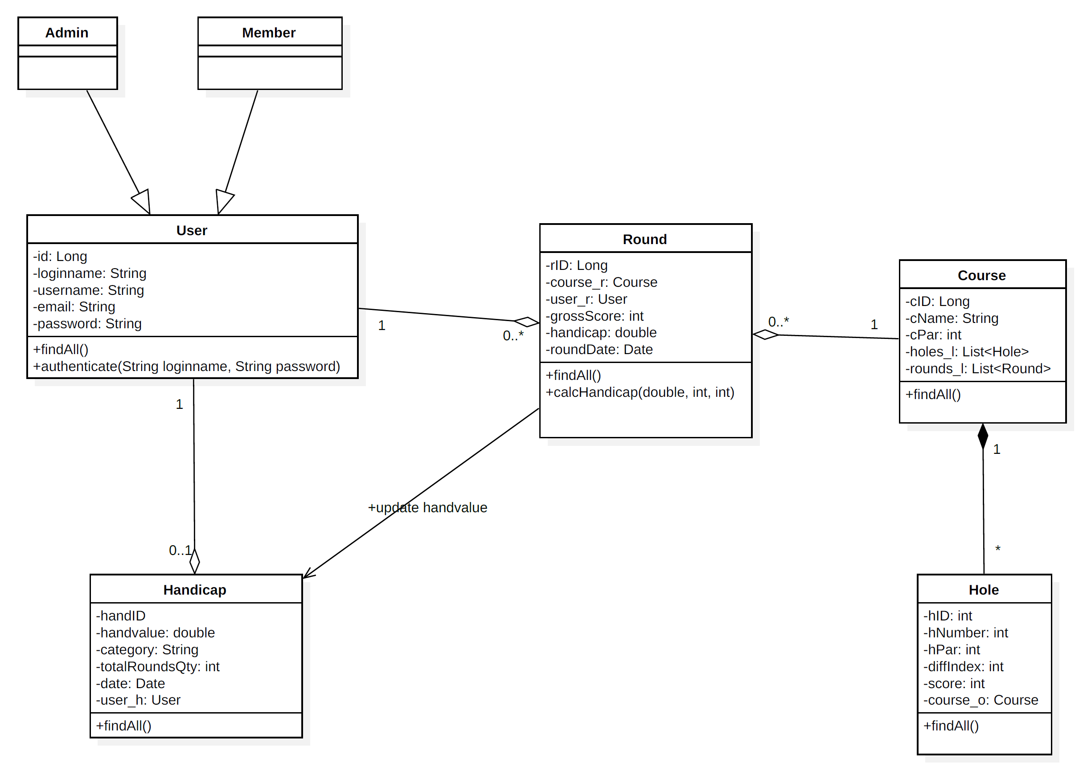

## Testing conducted

JUnit test was conducted to check the correctness of handicap calculation.

Initial values of initial handicap, total score and course par was inserted, and expecting value was added in assertion statement, delta value was added for double value in the range of +- 0.01.

@Test  
 public void testCalcHandicap(){  
 double outHand;  
 outHand = *calcHandicap*(6.3, 70, 72);  
 *assertEquals*(5.5, outHand, 0.01);  
 }

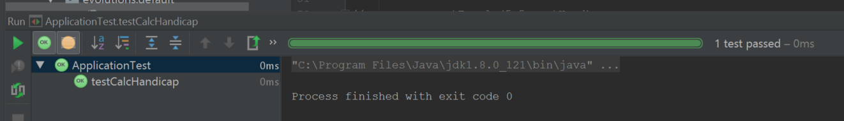

Test passed successfully.